**Agile processes:** We use Agile process for develop our site. Flow diagram and description mention bellow.

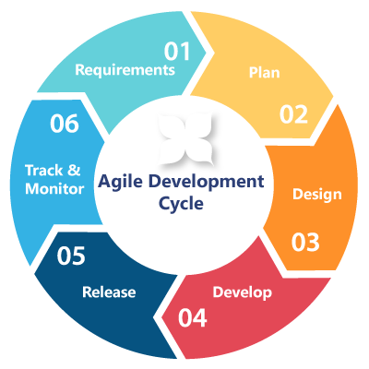

1. Requirements: We create requirement documentation for our project.
2. Plane: We plan our work flow and desired product.
3. Design: Whole design is done in this section. One student is assigned for this task.
4. Develop: It divided into two part
   1. Theme development. Two students are assigned for this task.
5. Release: We release the site into live site.
6. Track & Monitor: Here we track and monitor the site.